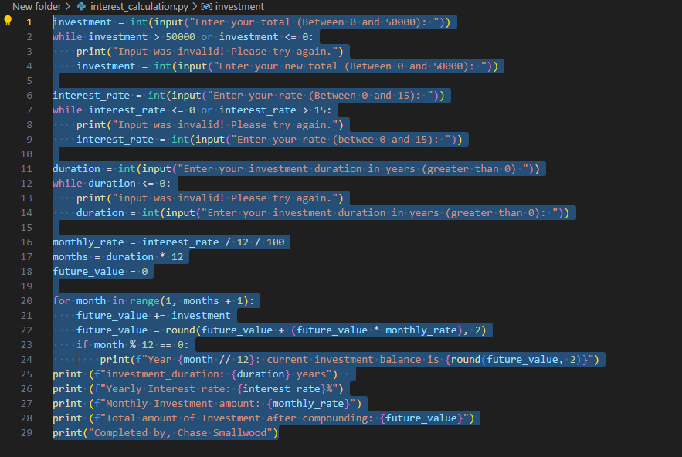

investment = int(input("Enter your total (Between 0 and 50000): "))
while investment > 50000 or investment <= 0:
print("Input was invalid! Please try again.")
investment = int(input("Enter your new total (Between 0 and 50000): "))

interest_rate = int(input("Enter your rate (Between 0 and 15): "))
while interest_rate <= 0 or interest_rate > 15:
print("Input was invalid! Please try again.")
interest_rate = int(input("Enter your rate (betwee 0 and 15): "))

duration = int(input("Enter your investment duration in years (greater than 0) "))
while duration <= 0:
print("input was invalid! Please try again.")
duration = int(input("Enter your investment duration in years (greater than 0): "))

monthly_rate = interest_rate / 12 / 100
months = duration * 12
future_value = 0

for month in range(1, months + 1):
future_value += investment
future_value = round(future_value + (future_value * monthly_rate), 2)
if month % 12 == 0:
print(f"Year {month // 12}: current investment balance is {round(future_value, 2)}")
print (f"investment_duration: {duration} years")
print (f"Yearly Interest rate: {interest_rate}%")
print (f"Monthly Investment amount: {monthly_rate}")
print (f"Total amount of Investment after compounding: {future_value}")
print("Completed by, Chase Smallwood")

